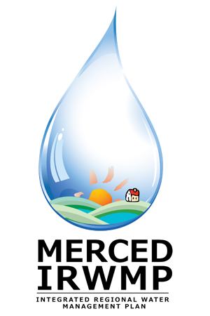

Merced Integrated Regional Water Management (IRWM) Plan
Regional Advisory Committee Meeting #8
Tuesday December 18, 2012
2:00 pm – 5:00 pm
The Sam Pipes Room
1st floor of the Civic Center (City Hall)
678 W. 18th Street
Merced, CA 95340

- Introductions and Overview 15 Min
- DWR Update 5 Min
- RAC Activities and Materials 10 Min
- Workgroup Reports 15 Min
- Governance 20 Min
- Summary of Technical Studies 90 Min
  - Water Conservation
  - Integrated Flood Management
  - Groundwater Recharge
  - Salt and Nutrient Management
  - Climate Change
- Implementation Grant Update 15 Min
- Next Steps 5 Min
- Public Comment 5 Min

